About the original authors:

Dragon Enchained is literally a cottage industry. We live in the forest, near a state park, a small river and a narrow-gauge railroad which hosts reenactment events. Town is half a mile up the road.

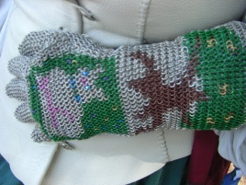Christopher M. Albrecht has been a chainmaille builder since 2007, having taught himself to make maille when his wife, a fencer in the Society for a Creative Anachronism, voiced a desire for a chainmaille parrying glove.

He has been a programmer since the late 1970s, working professionally on image processing software, including early versions of the TigerView x-ray software you may have seen in your dentist’s office.

He and his wife used the Irregular Grid Painter software to visualize some chainmaille projects, but quickly became frustrated at its limitations, especially the lack of zoom function. He set out to correct the problems, and Chainmaille Designer is the result.

His wife, Elsa DieLöwin, designs chainmaille projects, but leaves the execution to him and his exacting standards. She has made images for DECD, but spends more time on knitting and historic costuming.

|  |
| --- |
| If you have experience using IGP… |
| Chainmaille Designer is backward compatible with designs and chainmaille weaves developed for IGP.  IGP designs being opened in Chainmaille Designer for the first time need to have the weave specified. CD then remembers the weave, and our various additional features kick in.  CD allows zoom, even of old IGP designs.  With CD, the palette can be customized to the correct the colors of your rings, and both corrections and palette are saved with your design.  The overlay feature can be used to check the accuracy of your old IGP design against an intended image.  European 4-in-1 and Dragonscale designs can be opened using our new definitions of the weaves, which allow accurate portrayal of edges and corners. |
|  |
|  |
| Chainmaille Designer is FREE.  Find it at https://github.com/CMAlbrecht/ ChainmailleDesigner |
|  |
|  |

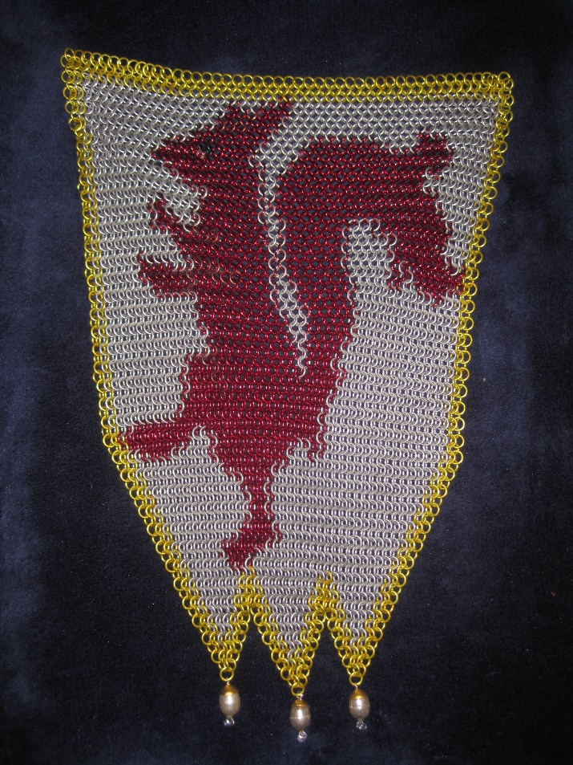

Introducing the Chainmaille Designer

An inlay planning tool for chainmaille makers

Some of what you will find in the Chainmaille Designer program:

|  |  |  |
| --- | --- | --- |
|  |  | The color counts report provides you with a count of the rings you will need, to make ordering accurately easier. |
| Our “Ringlord Standard Colors” palette is included with the software. | Example shows “Water Dragonscale” bracelet, with aluminum large rings and rubber small rings. Note the zoom tools at the bottom of the window. Zooms can also be done using your mouse wheel. Note also that the edge rings are clear, showing exactly what the bracelet will look like. | Download now  for FREE from github.com/CMAlbrecht/ ChainmailleDesigner  Thanks for your interest! |
| The palette makes it easy to assign colors to your mouse buttons. Currently assigned colors show on the rings at the top. |  | The design windows store information about your project, making it easier to keep track of |
|  | The zoom goes in far enough for you to be certain of which ring it is that is receiving a color assignment. | multiple similar projects. |

|  |
| --- |
|  |
| The overlay tool makes it possible to accurately reproduce extant graphics, from logos to photographs. The only limits are the resolution of your weave and the range of your colors. |
|  |
| Your designs can be specified in units of maille or by measurement, with or without wraps. The point of view is of building the maille. |
|  |
| If you find that you need to alter the numbers of rings, rows, or columns, the change design tool makes that easy. No need to start again from scratch! |